-22AIE203-  
Data structures and algorithms -2

**Name: Girish S Roll No.: AM.EN.U4AIE22044**

# ASSIGNMENT 6 – Radix Sort

--------------------------------------------------------------------------

Counting Sort

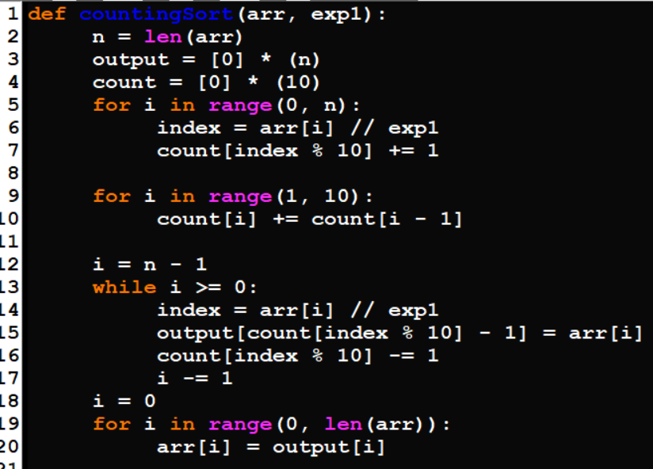

Radix Sort

